CERTIFICATE OF ANALYSIS
(CHINA LANGCHEM INC.)

Product ID: 2023 CAS: 706779-91-1

Product: Pimavanserin Batch NO.: LC-2009090909

Manufacture Date: 2009-09-09 Analysis Date: 2009-09-10

Structure:
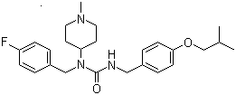

Formula: C25H34FN3O2
Molecular Weight: 427.55
Inspection Standard Results
Appearance: Light yellow solid Conformed
Purity (HPLC): 97% 98.5%
Single Impurity Peak : ≤0.5% <0.3%
HNMR: Conformed
Mass: Conformed
Storage: Stored in a cool dry place
Retest Date: One year
Conclusion: This product by inspection accords with the standard corporation.

