CERTIFICATE OF ANALYSIS

Manufacture Date: | 2011-10-22
Batch NO: | 20111022

Product ID | 10410
Product Name: | Atorvastatin calcium
CAS: | 134523-03-8
Formula: | 2(C33H34FN2O5).Ca
Molecular Weight: | 1155.36
Structure: | 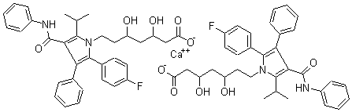
Items | Inspecition Standard | Results
Character: | A White or almost white crystalline powder |  | A White crystalline powder
Specific Optical Rotation: | -7.0~-9.0 |  | -8.2
Water%: | 3.5-5.5 |  | 4.5
Ga%: | 3.0~3.6 |  | 3.4
H eavy Metals(ppm) : | ≤10 |  | ＜10
Impurity  (HPLC) | Atorvastatin Lactone |  | ≤0.15% |  | Conform
Impurity  (HPLC) | Desfluoro-atorvastatin calcium |  | ≤0.15% |  | Conform
Impurity  (HPLC) | Diamine-atorvastatin calcium |  | ≤0.15% |  | Conform
Impurity  (HPLC) | Isomer-atorvastatin calcium |  | ≤0.15% |  | Conform
Impurity  (HPLC) | Other individual unknown impurity% | ≤0.15% |  | Conform
Impurity  (HPLC) | Total impurity | ≤1.0% |  | 0.5%
Assay%: | 98.0-102.0 | 99.4
Conclusion: | This product by inspection accords with the standard corporation.

