CERTIFICATE OF ANALYSIS

Manufacture Date: | 2011-03-08
Batch NO: | 20110308

Product ID | 17103
Product Name: | Quinine
CAS: | 130-95-0
Formula: | C20H24N2O2
Molecular Weight: | 324.42
Structure: | 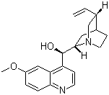
Items | Inspecition Standard | Results
Appearance: | White to off white powder |  | Almost white powder
Assay: | 95% | 97%
MP: | 173-175℃ | 174.0-174.8℃
Storage: | Stored in a cool dry place.
Conclusion: | This product by inspection accords with the standard corporation.

