CERTIFICATE OF ANALYSIS

Manufacture Date: | 2016-04-26
Analysis Date: | 2016-04-27
Batch NO.: | 20160426

Product ID | 29566
Product Name: | N-(2,4-DIMETHYLPHENYL)-N'-(3-METHOXYBENZYLIDENE)ACETOHYDRAZIDE
CAS: | 1146963-51-0
Formula: | C18H17F3N2O2
Molecular Weight: | 350.3349896
Structure: | 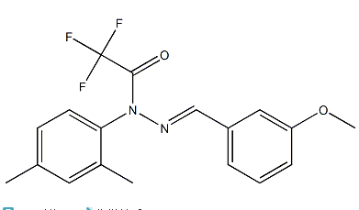
 | Inspection Standard | Results
Appearance: | Light Yellow Powder | complies
Assay display: | 98%min | 98.3%
Storage: | Stored in a cool dry place.
Conclusion: | This product by inspection accords with the standard corporation.

